Formulae
Z table :
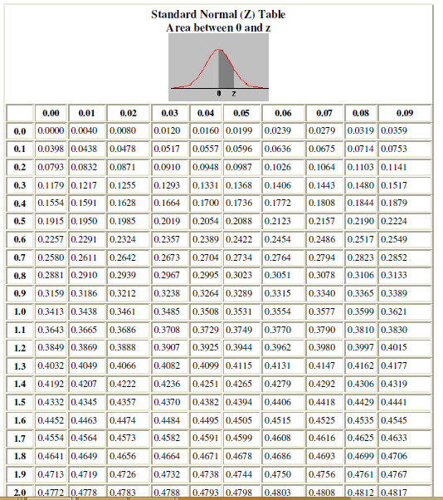
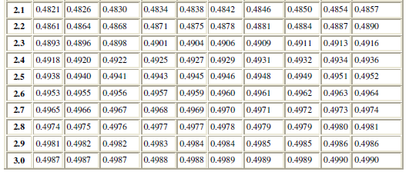

Binomial Distributions:
The probability that a random variable X with binomial distribution B(n,p) is equal to the value k, where k = 0, 1,....,n , is given 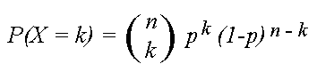
where
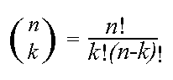
And Mean and variance formulae
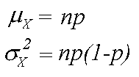

Conditional Probability
Prob of A given B
P(A|B) = P(A ∩B)/P(B) (given that P(B) > 0)

Bayes’s rule:
P(B|A) = P(A|B)∗P(B)/P(A)
Also, P(A) = P(A|B)*P(B) + P(A|B’)*P(B’)
Thus, P(B|A) = P(A|B)∗P(B) / P(A|B)∗P(B) + P(A|B’)∗P(B’)

Law of Total Probability:

The total probability rule (also called the Law of Total Probability) breaks up probability calculations into distinct parts. It’s used to find the probability of an event, A, when you don’t know enough about A’s probabilities to calculate it directly. Instead, you take a related event, B, and use that to calculate the probability for A.
The probability for a can be written as sums of event B. The total probability rule is:

P(A) = P(A∩B) + P(A∩B^{c}).

Note: ∩ means “intersection” and B^{c} is the complement of B.

Normal Distribution

